**Chapel Street Nursery School invites you to the**



Saturday 13th July at 10am – 12pm

****Come and enjoy activities, games and refreshments at our Summer Extravaganza!

**There will be lots of fun games, refreshments, things to buy and make and a special appearance from Pepper Pig.**

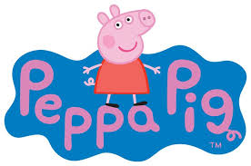

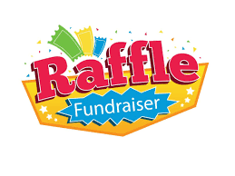**If you would like to have use of a Table to sell anything, please call 01582 413552 to book one. There is limited availability and the cost is £10 per table (you can supply your own table but booking is still required and the charge is £10 for a spot)**

**All proceeds will go towards buying resources for the nursery.**

**We plan to hold it in the garden, weather permitting!**

****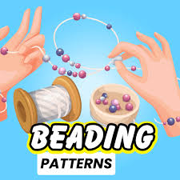**Come along and join in the fun. We look forward to seeing you.**